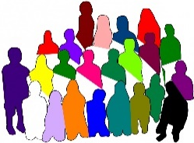
Advisory Group.
The Advisory Group is a group of 10 people who share their ideas to help guide a project.
They will meet every two months.
They will pick what day and what time they meet.
Meetings will be either online or in-person.
They will be paid $280 for every meeting they attend.

If you want to join the Advisory Group, you need to:
- be over 18,
- have psychosocial disability or mental illness or use mental health services,
- be interested in the NDIS or be on the NDIS,
- be able to attend meetings every two months.

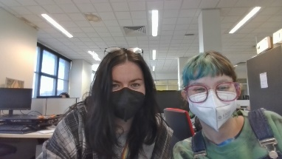
TJ and Is will run the meetings.
In meetings we will talk about:
- what is happening in the project,
- what the group thinks about things, and
- topics about the project.

The group will make their own rules about how it will run.

Group members can share as much as they want during the group.
If you want to join the group you need to fill out a form to share your interest.

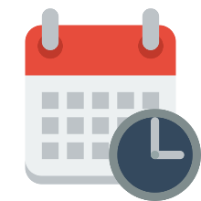
The form will be open until 11:59pm on Sunday October 29th 2023.
We will let you know if you are in the group before Friday November 3rd 2023.
Click here to fill out the form if you want to join the group.

You can contact us if you need help filling out the form or if you have any questions.
Phone:
Email:

