Co-design Groups
From December 2023 to June 2024 we will run 10 co-design groups.
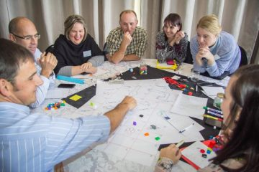
A co-design group is when a group of people design or make something together.

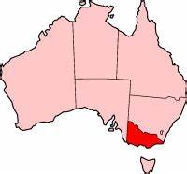
The groups will run across Victoria.

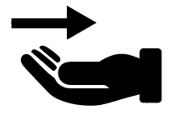
These sessions will talk about:
- what your needs are,
- what you want,

- what your rights are in the NDIS, and
- what you want to make.

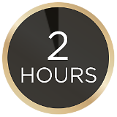
The co-design groups go for 2-hours.
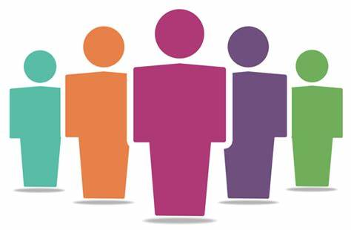
Each group will have 5 people in it.
You can only do one group.
You will be paid $175 for doing a group.

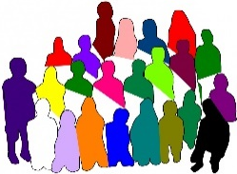
If you want to join a Co-design group, you need to:
- not be on the Advisory Group,
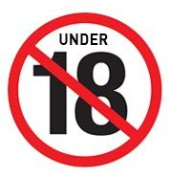
- be over 18,
- have psychosocial disability or mental illness or use mental health services,
- be interested in the NDIS or be on the NDIS,
- be able to attend one 2-hour session.
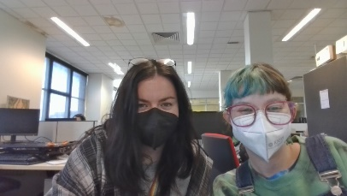

TJ and Is will run the groups.

The group will make their own rules at the start.
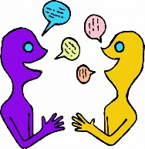
Everyone will be helped to share their thoughts.
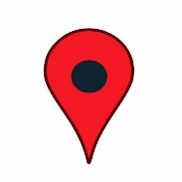
The group will get to pick when and where they meet.
If you want to join the group you need to fill out a form to share your interest.

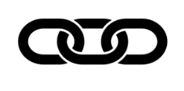
Click here to fill out the form if you want to join the group.

You can contact us if you need help filling out the form or if you have any questions.
Phone:
Email:

