Meet the Team
This is TJ.
TJ uses she and they pronouns.
TJ is the Project Coordinator. This means they run the project.
TJ is queer.
They speak up for mental health.

They work with young people in Melbourne.
TJ has experience of mental illness and using mental health services.
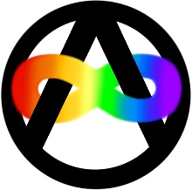
TJ is neurodivergent. This means their brain works differently from other people.

They want to work with people who also have mental illness.
They want people to have their voices heard.

They want people to have their rights met by the NDIS.

They want to help people fight for change.

This is Is.
Is uses they and them pronouns.
Is is the Project Officer. This means they help run the project.
Is is:
- disabled,
- queer and
- trans.

They care about the world being fair to people with different experiences.
They want to make sure people have what they need to have their rights met and make change.

You can contact us if you want to know more about TJ and Is or the project.
Phone:
Email:

