PPE for community service* providers
for prevention of COVID-19
*Disability services, out of home care residential services, family violence and sexual assault services, child and family services, child protection or other essential community (non-health) services

Last updated: 1 May 2020

Who is this guidance for?
The following guidance applies to outreach home-based care, residential care and client visits. In-home care (foster and kinship carers) and other household members should follow the guidance provided by the department to cases, suspected cases and close contacts.
For returned travellers in hotel quarantine local procedures for PPE requirements must be followed.

What personal protective equipment (PPE) is required?
Wherever possible, if the client is determined to have any of the risk factors listed, the appointment should be postponed until there are no longer any risk factors (for example, end of quarantine for close contact). Appointments should also be kept as brief as possible to minimise risk of transmission.
Staff should use PPE as outlined in Table 1 for clients who meet any of the following risk factors:
- suspected (that is awaiting a COVID-19 testing result) or confirmed as having COVID-19
- fever or chills (in the absence of an alternative diagnosis that explains the clinical presentation) OR have symptoms of an acute respiratory infection (for example, cough, sore throat, shortness of breath or runny nose)
- have been advised by DHHS they are a close contact of someone with confirmed COVID-19 and are in quarantine for 14 days¹, or
- where you cannot determine whether the client or anyone in their home is at risk of having COVID-19 because you cannot get in contact with them or they refuse to answer².
If any of the above risk factors are identified, the client should also, wherever possible, wear a surgical mask.
Table 1: PPE to use when clients have COVID-19 risk factors
For use when | 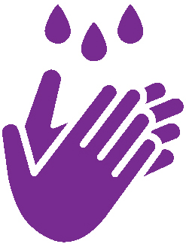  Hand hygiene | 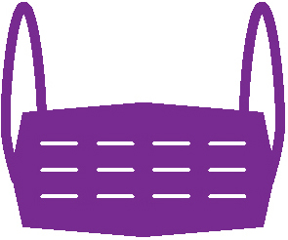  Surgical mask | P2/N95  respirator/  mask | Eye protection  (Safety glasses/  goggles/face shield) | 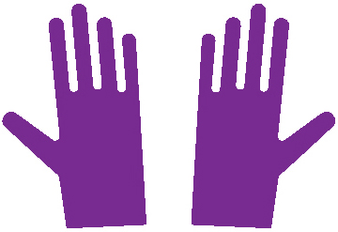  Gloves | Disposable fluid repellent gown
Providing care that involves touching the client or contact with blood or body fluids³
Providing non-contact care or support and can’t maintain physical distancing (> 1.5 metres)
Providing non-contact care or support and can maintain physical distancing (> 1.5 metres)⁴
¹ If a client who has returned from overseas in the last 14 days or has been advised by DHHS that they are a close contact of someone with confirmed COVID-19, and develops symptoms of COVID-19, then they should be tested for COVID-19. Continue to use these precautions while awaiting test results.
² Client breaches of social distancing measures does not require them to be treated as a suspected case.
³ Includes where there is known deliberate spitting/coughing on staff
⁴ Only includes when time spent with the client in an enclosed space (e.g. in the same room) will be for less than two hours. If time spent with the client will be for longer than two hours, then use of a surgical mask will be required for all non-contact care.
Note: that if a client is confirmed as having COVID-19 all other residents in that house will likely be considered close contacts and the same precautions will then be required for all clients in that residential setting.
Table 2: PPE to use when clients do not have COVID-19 risk factors or have been cleared of COVID-19.
 | Hand hygiene | Surgical mask | N95/P2 mask | Eye protection  (Safety glasses/  goggles/face shield) | Gloves | Disposable fluid repellent gown or plastic apron
Providing care that may involve exposure to blood, body fluids, touching mucous membranes or non-intact skin |  | +/-  If splash to face anticipated |  | +/-  If splash to eye anticipated |  | +/-  If splash or contamination of body anticipated
Providing non-contact care or support
Please also see the Guide to the conventional use of personal protective equipment (PPE) <https://www.dhhs.vic.gov.au/health-services-and-general-practitioners-coronavirus-disease-covid-19>.

Sequence for putting on and removing PPE
Refer to the department’s coronavirus website at https://www.dhhs.vic.gov.au/health-services-and-general-practitioners-coronavirus-disease-covid-19 where there are posters describing how to safely don (put on) and doff (remove) PPE.

Disposal of PPE
If PPE is not contaminated, that is blood or body fluid is not visible, it can be disposed of in general waste.
If PPE has been contaminated, that is blood or body fluid is visible, it should be disposed of in the following manner:
- Remove and place in sealable plastic bag.
- Transport and store in a secure area. It will need to be disposed of as clinical waste.

